1-SQL storage engines

✅ What is a Storage Engine in MySQL?
# Source: AI Source: Provided by: [Data Path: Persons Table -> ID Column: 1, Name_En Column: Motasem Essam] -> From: [ChatGPT] on [6/11/2026]
A storage engine in MySQL is the software module that handles how data is stored, retrieved, and managed in a table.
Think of it as the "under-the-hood" system that powers a table. Different engines offer different features like transactions, locking, performance optimizations, and data integrity.

⚙️ Common Storage Engines in MySQL
# Source: AI Source: Provided by: [Data Path: Persons Table -> ID Column: 1, Name_En Column: Motasem Essam] -> From: [ChatGPT] on [6/11/2026]
Engine | Description
InnoDB | ✅ Default engine. Supports transactions, foreign keys, row-level locking, crash recovery
MyISAM | 📚 Legacy engine. Fast for read-heavy operations but ❌ no transactions or foreign keys
MEMORY | 🧠 Stores all data in RAM. Extremely fast but volatile (data lost on restart)
CSV | 💾 Stores data in plain-text CSV format. Easy to export/import, limited features
ARCHIVE | 🗄️ Optimized for storing large historical data. Insert-only, highly compressed
BLACKHOLE | 🕳️ Accepts data but discards it. Used for replication or logging testing

🔧 1. InnoDB (✅ Default in modern MySQL)
# Source: AI Source: Provided by: [Data Path: Persons Table -> ID Column: 1, Name_En Column: Motasem Essam] -> From: [ChatGPT] on [6/11/2026]

✅ Key Features:
- Supports Transactions (ACID-compliant)
- Row-level locking → better performance in high-concurrency environments
- Foreign key constraints → for relational integrity
- Automatic crash recovery (via redo logs)
- Data stored in clustered index (primary key data)
📦 Use When:
- You need data consistency and integrity
- You have high-write or concurrent workloads
- You use transactions and rollback/commit logic
❌ Drawbacks:
- Slightly slower on simple read-only queries than MyISAM
- Uses more disk and memory

📚 2. MyISAM (Legacy engine)
# Source: AI Source: Provided by: [Data Path: Persons Table -> ID Column: 1, Name_En Column: Motasem Essam] -> From: [ChatGPT] on [6/11/2026]

✅ Key Features:
- Table-level locking (not row-level)
- Good for read-heavy workloads
- Compact storage format
- Supports FULLTEXT indexing before InnoDB did
📦 Use When:
- You need fast reads and simple queries
- You don't need transactions or foreign keys
❌ Drawbacks:
- ❌ No transaction support
- ❌ No foreign keys
- ❌ Table locks can slow down writes
- ❌ Poor crash recovery (requires REPAIR TABLE)

🧠 3. MEMORY (aka HEAP)
# Source: AI Source: Provided by: [Data Path: Persons Table -> ID Column: 1, Name_En Column: Motasem Essam] -> From: [ChatGPT] on [6/11/2026]
✅ Key Features:
- Stores all data in RAM (not persistent)
- Extremely fast read/write
- Good for temporary or session-based data
📦 Use When:
- You need ultra-fast access to small, temporary tables
- Caching lookups or reference data
❌ Drawbacks:
- ❌ Volatile (data is lost on server restart)
- ❌ No BLOB/TEXT columns allowed
- Table size limited by memory

📄 4. CSV
# Source: AI Source: Provided by: [Data Path: Persons Table -> ID Column: 1, Name_En Column: Motasem Essam] -> From: [ChatGPT] on [6/11/2026]
✅ Key Features:
- Data stored in CSV (comma-separated values) files
- Simple, human-readable format
- Good for import/export scenarios
📦 Use When:
- You want a quick way to export or read tabular data
- Integration with spreadsheets or flat files
❌ Drawbacks:
- ❌ No indexing
- ❌ No constraints
- ❌ Poor performance
- ❌ No transactions

🗄️ 5. ARCHIVE
# Source: AI Source: Provided by: [Data Path: Persons Table -> ID Column: 1, Name_En Column: Motasem Essam] -> From: [ChatGPT] on [6/11/2026]
✅ Key Features:
- Used for storing large amounts of historical data
- Highly compressed storage
- Insert-only operations (no updates or deletes)
- Optimized for fast bulk inserts
📦 Use When:
- You want to store logs or data that won't change
- You need to archive large data sets efficiently
❌ Drawbacks:
- ❌ No indexes (except auto-increment)
- ❌ No deletes or updates
- ❌ Slower reads compared to others

🕳️ 6. BLACKHOLE
# Source: AI Source: Provided by: [Data Path: Persons Table -> ID Column: 1, Name_En Column: Motasem Essam] -> From: [ChatGPT] on [6/11/2026]
✅ Key Features:
- Acts like a “null sink”: accepts data, but discards it
- Useful for replication setups, where you want to log changes but not store them
📦 Use When:
- Testing triggers or replication
- Logging queries without storage impact
❌ Drawbacks:
- ❌ Data not stored
- ❌ No SELECT results possible
- ❌ Only good for advanced setups (not for beginners)

🧩 7. FEDERATED
# Source: AI Source: Provided by: [Data Path: Persons Table -> ID Column: 1, Name_En Column: Motasem Essam] -> From: [ChatGPT] on [6/11/2026]
✅ Key Features:
- Allows you to connect to a remote MySQL server’s table
- Access data from external databases like a local table
📦 Use When:
- You need to read/write data from a remote server
- Integrate distributed databases
❌ Drawbacks:
- ❌ Slower (depends on network)
- ❌ No transactions
- ❌ Limited support

📘 Summary Table
# Source: AI Source: Provided by: [Data Path: Persons Table -> ID Column: 1, Name_En Column: Motasem Essam] -> From: [ChatGPT] on [6/11/2026]
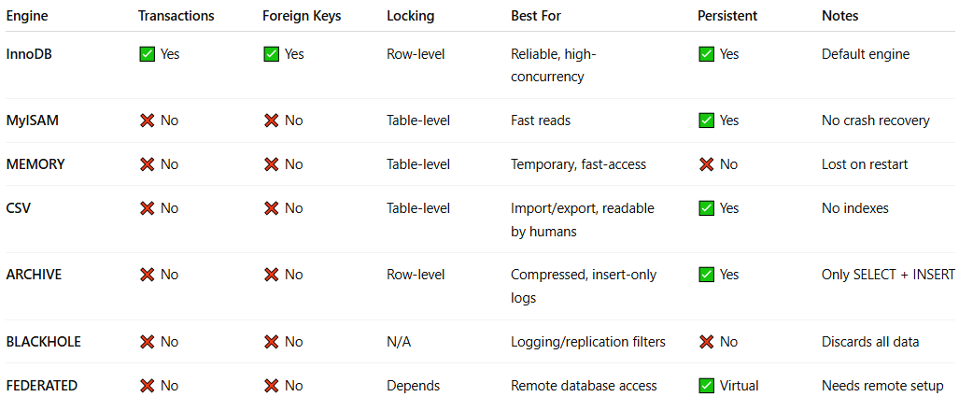
Engine | Transactions | Foreign Keys | Locking | Best For | Persistent | Notes
InnoDB | ✅ Yes | ✅ Yes | Row-level | Reliable, high-concurrency | ✅ Yes | Default engine
MyISAM | ❌ No | ❌ No | Table-level | Fast reads | ✅ Yes | No crash recovery
MEMORY | ❌ No | ❌ No | Table-level | Temporary, fast-access | ❌ No | Lost on restart
CSV | ❌ No | ❌ No | Table-level | Import/export, readable by humans | ✅ Yes | No indexes
ARCHIVE | ❌ No | ❌ No | Row-level | Compressed, insert-only logs | ✅ Yes | Only SELECT + INSERT
BLACKHOLE | ❌ No | ❌ No | N/A | Logging/replication filters | ❌ No | Discards all data
FEDERATED | ❌ No | ❌ No | Depends | Remote database access | ✅ Virtual | Needs remote setup

🔍 How to Check the Default Storage Engine
# Source: AI Source: Provided by: [Data Path: Persons Table -> ID Column: 1, Name_En Column: Motasem Essam] -> From: [ChatGPT] on [6/11/2026]
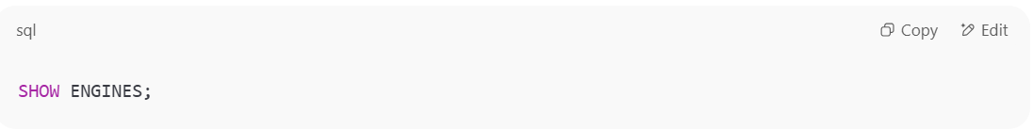
SHOW ENGINES;

You’ll see a list of available engines with DEFAULT next to the one currently used.

📐 Setting the Engine for a Table
# Source: AI Source: Provided by: [Data Path: Persons Table -> ID Column: 1, Name_En Column: Motasem Essam] -> From: [ChatGPT] on [6/11/2026]
You can specify the engine when creating a table:
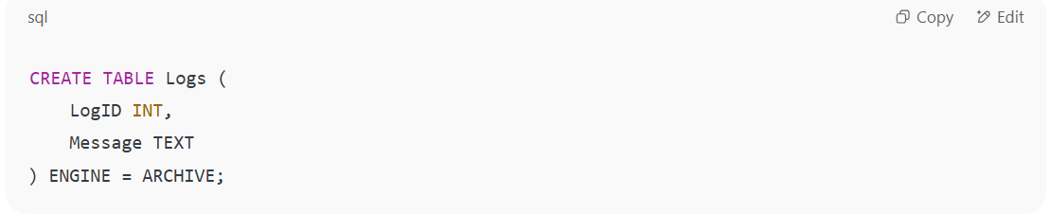
CREATE TABLE Logs (
LogID INT,
Message TEXT
) ENGINE = ARCHIVE;

If you don’t specify it, MySQL will use the default engine, which is usually InnoDB.

🛠️ Switching Engine for an Existing Table
# Source: AI Source: Provided by: [Data Path: Persons Table -> ID Column: 1, Name_En Column: Motasem Essam] -> From: [ChatGPT] on [6/11/2026]
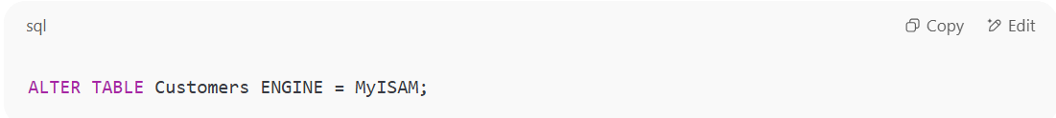
ALTER TABLE Customers ENGINE = MyISAM;

⚠️ Note: Be careful — changing engines may affect data integrity, performance, or supported features.

Check the storage engine
# Source: AI Source: Provided by: [Data Path: Persons Table -> ID Column: 1, Name_En Column: Motasem Essam] -> From: [ChatGPT] on [6/11/2026]
To check the storage engine of a table in MySQL, you can use one of the following methods:

✅ 1. Using SHOW TABLE STATUS
# Source: AI Source: Provided by: [Data Path: Persons Table -> ID Column: 1, Name_En Column: Motasem Essam] -> From: [ChatGPT] on [6/11/2026]
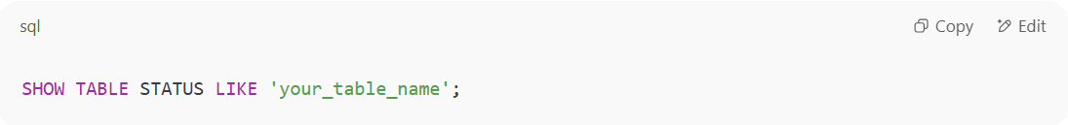
SHOW TABLE STATUS LIKE 'your_table_name';

- Look at the Engine column in the result to see which engine (e.g., InnoDB, MyISAM) the table uses.
📌 Example:
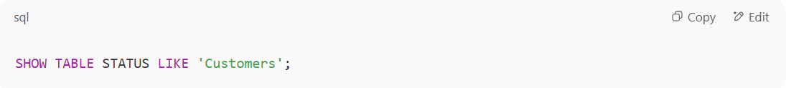
SHOW TABLE STATUS LIKE 'Customers';

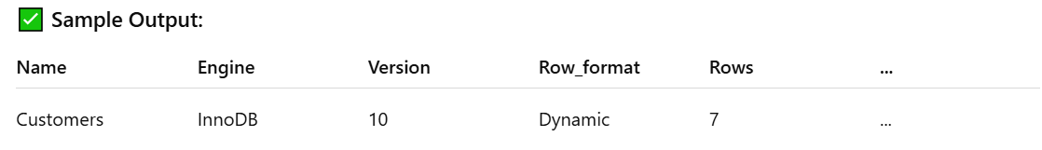

Name | Engine | Version | Row_format | Rows | ...
Customers | InnoDB | 10 | Dynamic | 7 | ...

🧠 Explanation:
- Engine: Shows InnoDB, MyISAM, etc.
- Row_format, Rows, Collation, etc., also included.

✅ 2. Using INFORMATION_SCHEMA
# Source: AI Source: Provided by: [Data Path: Persons Table -> ID Column: 1, Name_En Column: Motasem Essam] -> From: [ChatGPT] on [6/11/2026]
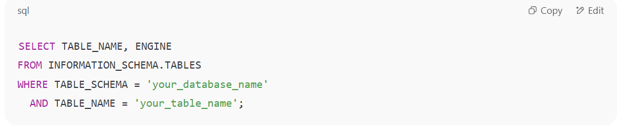
SELECT TABLE_NAME, ENGINE
FROM INFORMATION_SCHEMA.TABLES
WHERE TABLE_SCHEMA = 'your_database_name'
AND TABLE_NAME = 'your_table_name';

📌 Example:
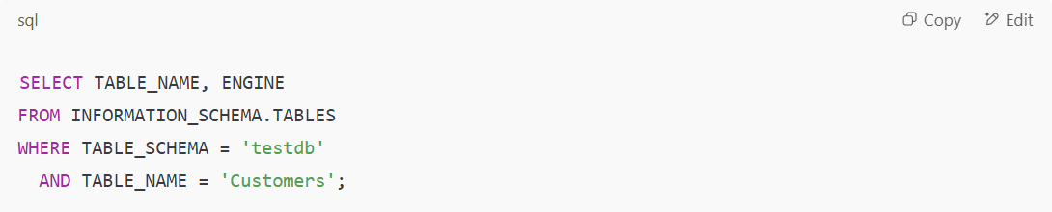
SELECT TABLE_NAME, ENGINE
FROM INFORMATION_SCHEMA.TABLES
WHERE TABLE_SCHEMA = 'testdb'
AND TABLE_NAME = 'Customers';

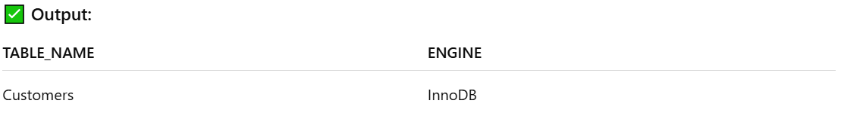

TABLE_NAME | ENGINE
Customers | InnoDB

✅ 3. Using SHOW CREATE TABLE
# Source: AI Source: Provided by: [Data Path: Persons Table -> ID Column: 1, Name_En Column: Motasem Essam] -> From: [ChatGPT] on [6/11/2026]
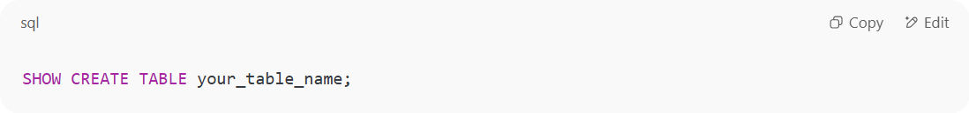
SHOW CREATE TABLE your_table_name;

It will display the full CREATE TABLE command, which includes the engine used:
📌 Example Output:
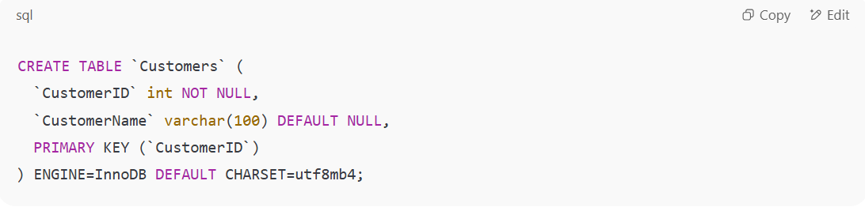
CREATE TABLE `Customers` (
`CustomerID` int NOT NULL,
`CustomerName` varchar(100) DEFAULT NULL,
PRIMARY KEY (`CustomerID`)
) ENGINE=InnoDB DEFAULT CHARSET=utf8mb4;

📌 Why It Matters
# Source: AI Source: Provided by: [Data Path: Persons Table -> ID Column: 1, Name_En Column: Motasem Essam] -> From: [ChatGPT] on [6/11/2026]
Each engine gives you trade-offs:
Feature | InnoDB | MyISAM | MEMORY
Transactions | ✅ | ❌ | ❌
Foreign Keys | ✅ | ❌ | ❌
Row Locking | ✅ | ❌ | ✅
Speed (Reads) | ⚖️ | ✅ | ✅
Crash Recovery | ✅ | ❌ | ❌
Data in Memory | ❌ | ❌ | ✅

Example

prepared commands
# Source: ScreenShot Source: Provided by: [Persons Table -> ID Column: 1, Name_En Column: Motasem Essam] -> Tool: [Automation Table -> ID Column: 16, Name_En Column: Screen Capture] -> From [Operating System: Wampserver64 -> phpmyadmin] on [6/11/2026]
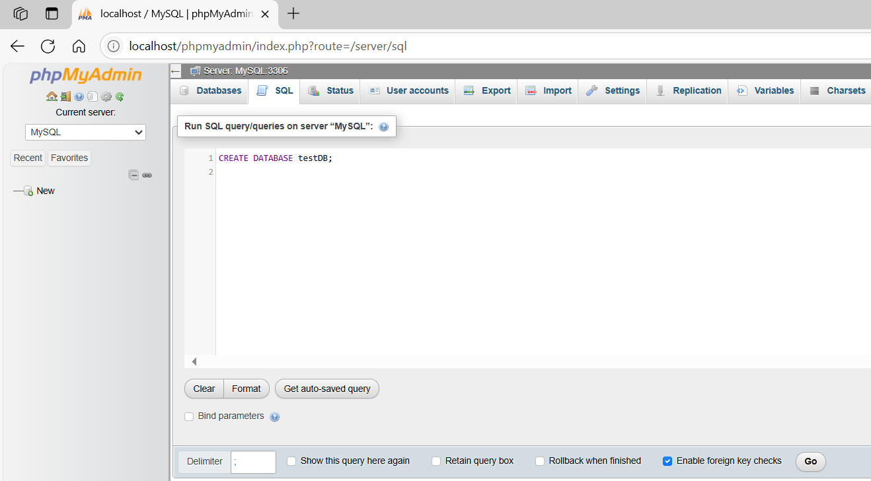
CREATE DATABASE testDB;
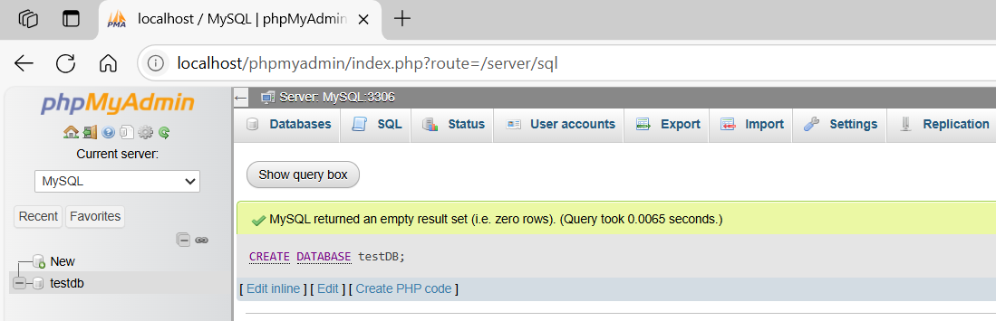

basic command
# Source: ScreenShot Source: Provided by: [Persons Table -> ID Column: 1, Name_En Column: Motasem Essam] -> Tool: [Automation Table -> ID Column: 16, Name_En Column: Screen Capture] -> From [Operating System: Wampserver64 -> phpmyadmin] on [6/11/2026]
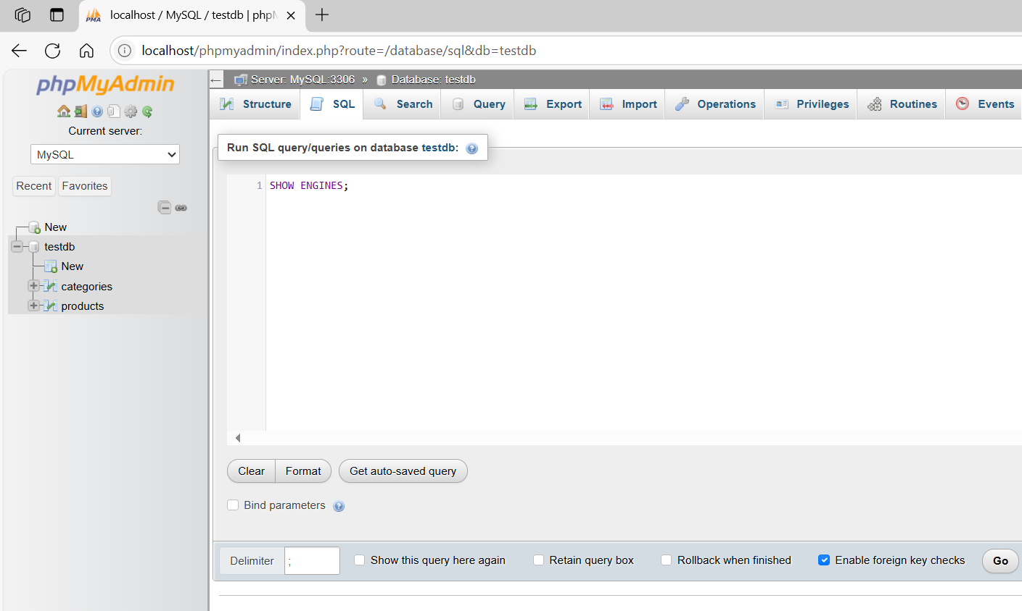
SHOW ENGINES;
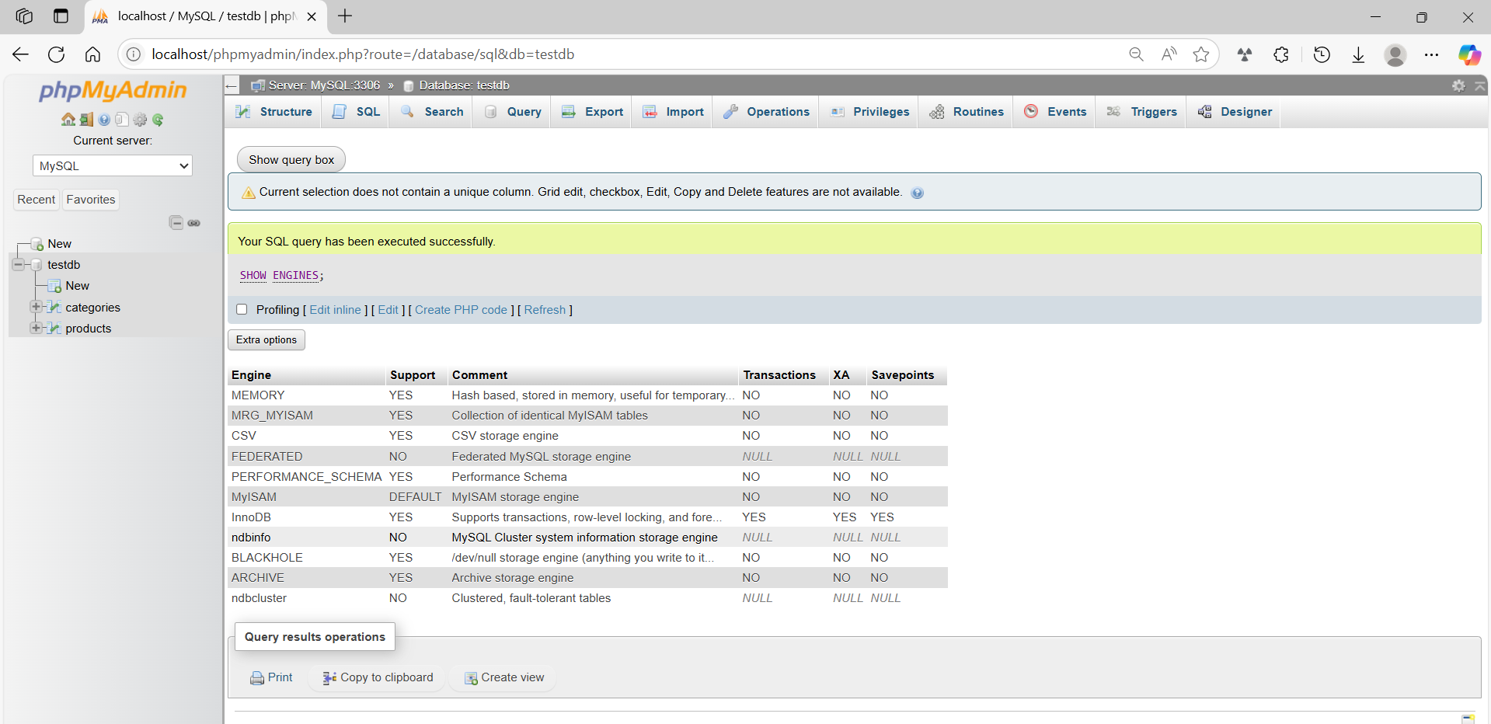

basic command
# Source: ScreenShot Source: Provided by: [Persons Table -> ID Column: 1, Name_En Column: Motasem Essam] -> Tool: [Automation Table -> ID Column: 16, Name_En Column: Screen Capture] -> From [Operating System: Wampserver64 -> phpmyadmin] on [6/11/2026]
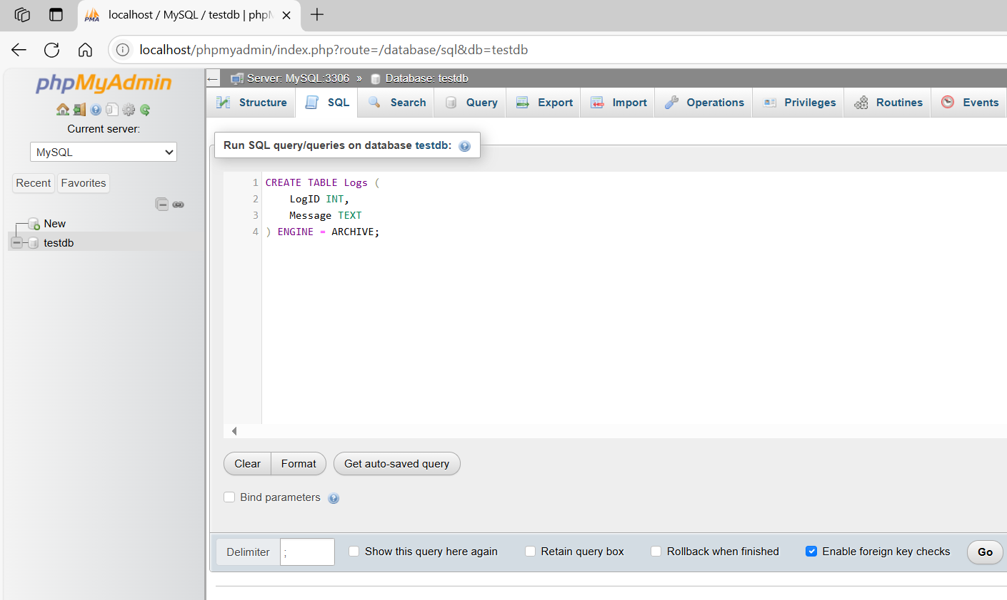
CREATE TABLE Logs (
LogID INT,
Message TEXT
) ENGINE = ARCHIVE;
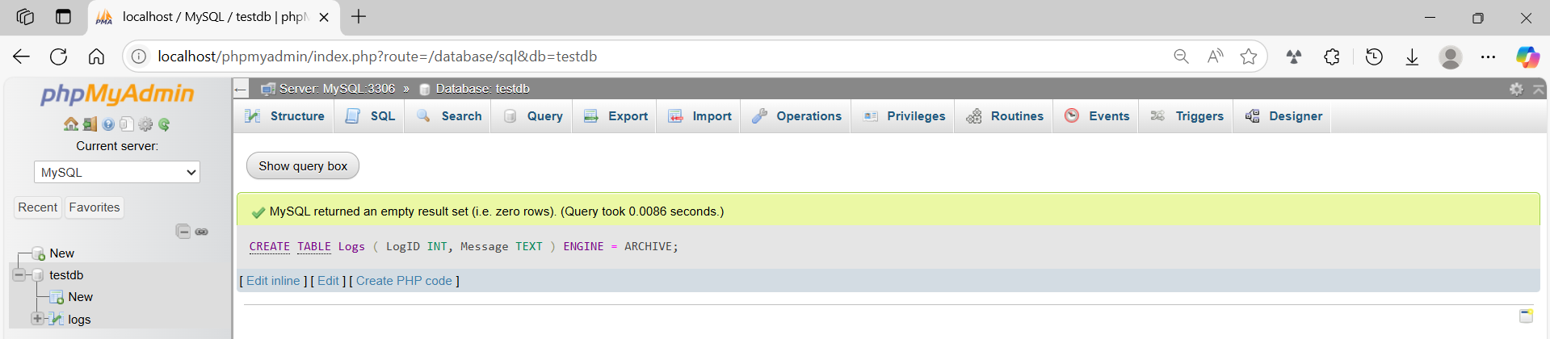

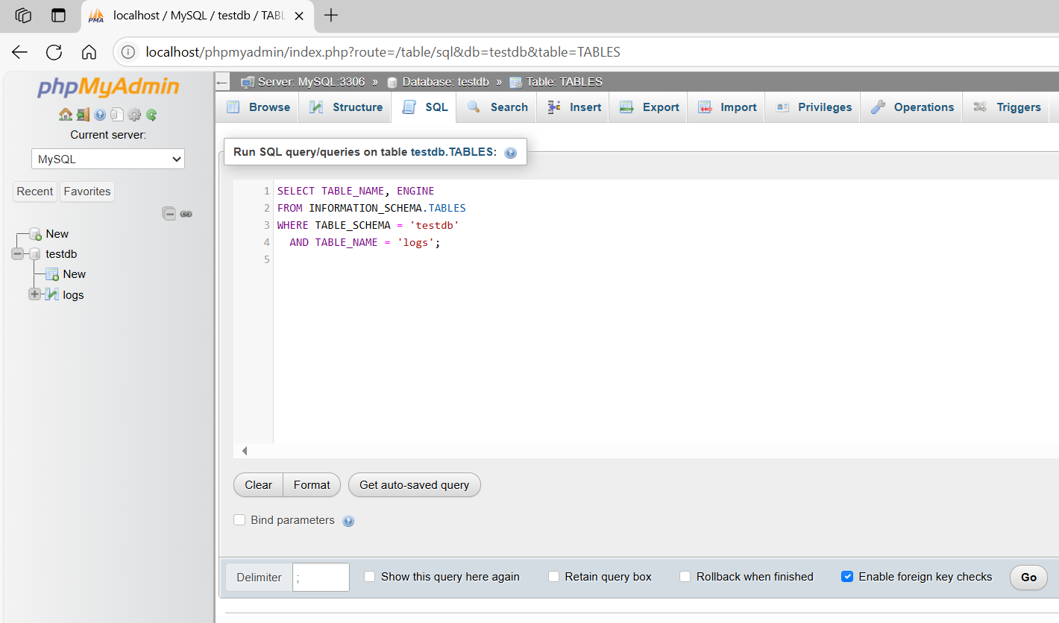
SELECT TABLE_NAME, ENGINE
FROM INFORMATION_SCHEMA.TABLES
WHERE TABLE_SCHEMA = 'testdb'
AND TABLE_NAME = 'logs';
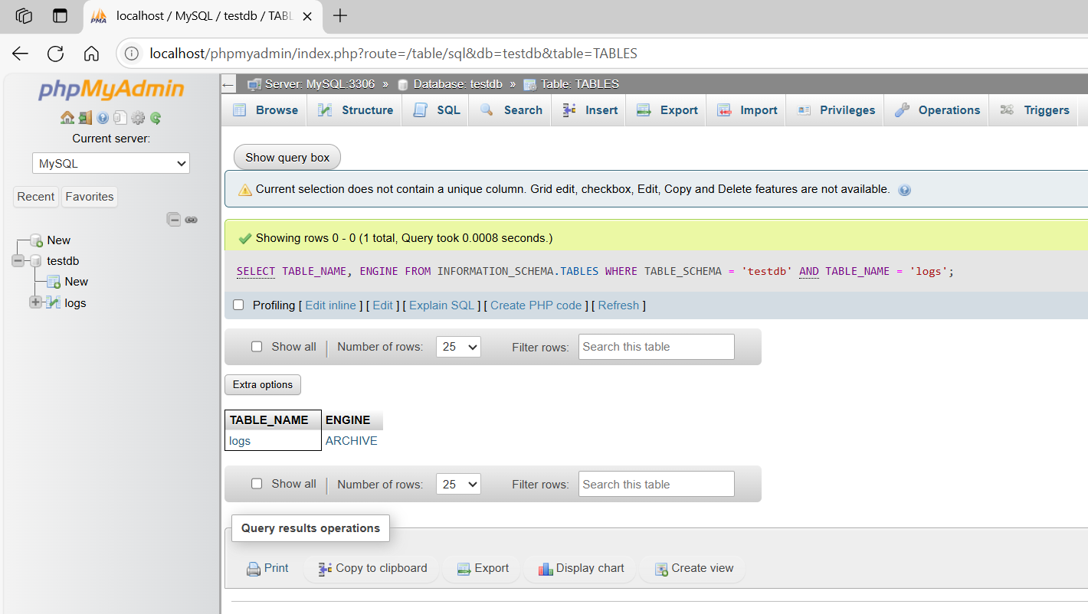

basic command
# Source: ScreenShot Source: Provided by: [Persons Table -> ID Column: 1, Name_En Column: Motasem Essam] -> Tool: [Automation Table -> ID Column: 16, Name_En Column: Screen Capture] -> From [Operating System: Wampserver64 -> phpmyadmin] on [6/11/2026]
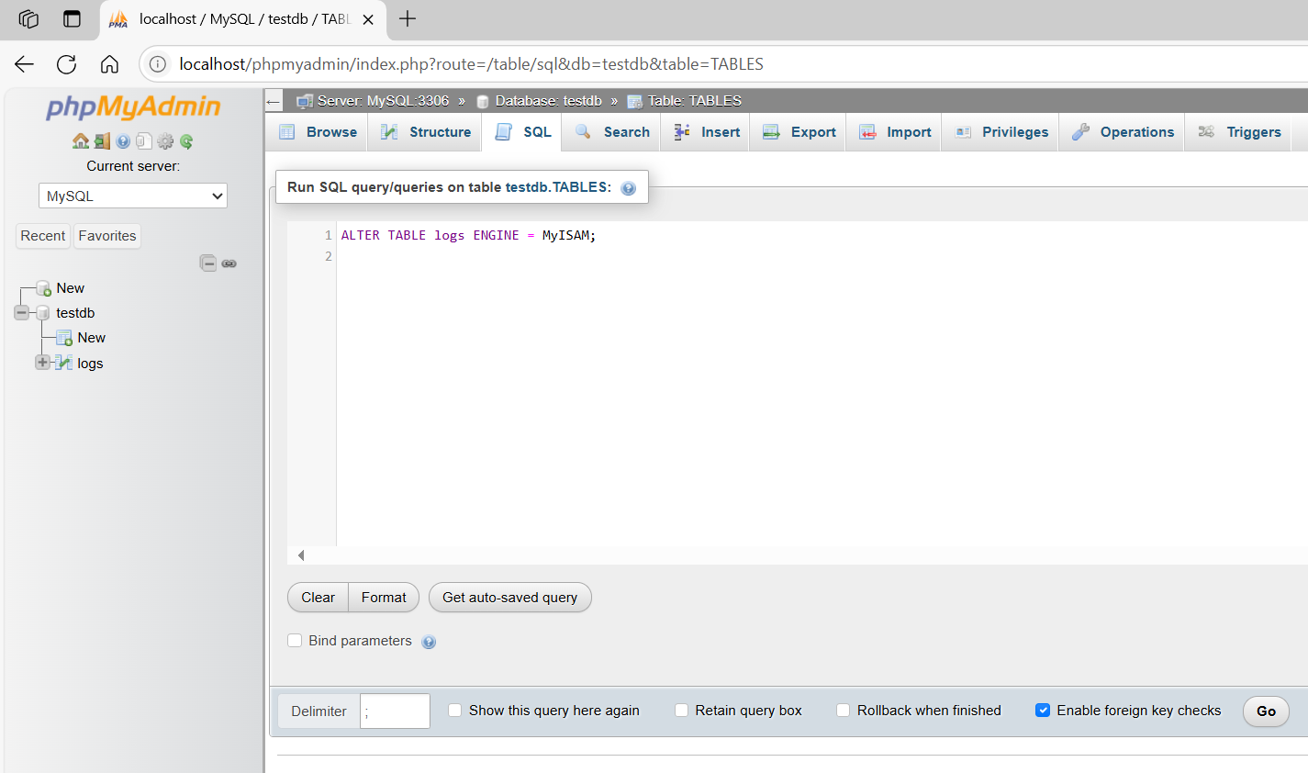
ALTER TABLE logs ENGINE = MyISAM;

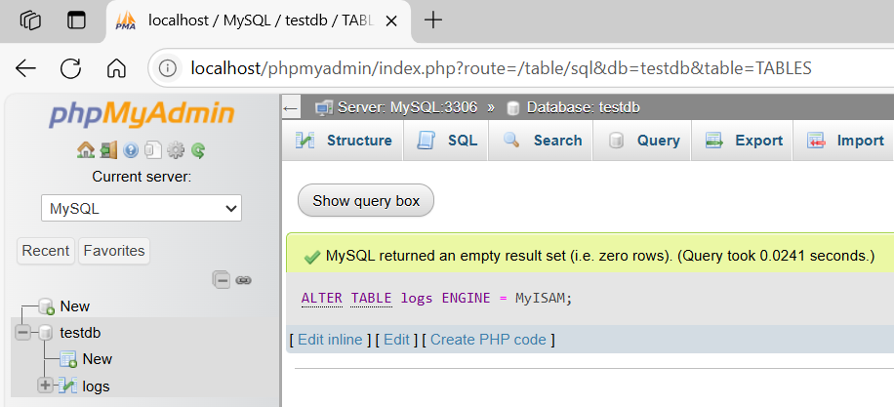

SELECT TABLE_NAME, ENGINE
FROM INFORMATION_SCHEMA.TABLES
WHERE TABLE_SCHEMA = 'testdb'
AND TABLE_NAME = 'logs';
